Phishing Quiz

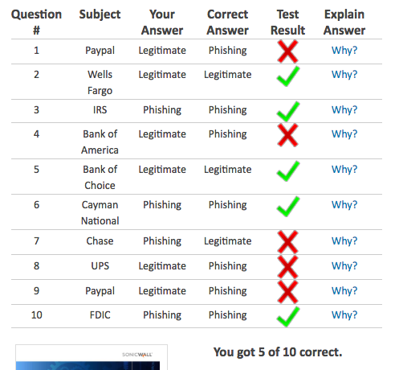

I was very surprised at my results. I thought I could easily spot a phishing email. The explanations were very helpful for the future. I now know to look for incorrect spelling, case, and links that don’t go to the actual website that is addressed. Another thing to be careful of is how the email addresses the recipient. “Member”, “Customer” , “Ma’am”, etc are all signs that it is probably not a legitimate email.